CapStone Project-

Sports Analysis

Geetha Vemula

**Overview:**

1. The analysis focuses on the comprehensive dataset of the Olympic Games, aiming to extract valuable insights from various dimensions, including sports, events, participants, medals, and regional representation.
2. The dataset comprises interconnected tables such as Sport, Event, City, Games, Games City, NOC Region, Person, Person Region, Games Competitor, Medal, and Competitor Event, offering a detailed perspective on the Olympics' historical data.
3. The Sport Table provides a list of all sports featured in both summer and winter editions, further categorized into specific events, covering a diverse range of athletic disciplines.
4. The Event Table offers detailed information on events within each sport, categorized by gender (Men's, Women's, and Mixed), providing insights into the diversity of competitions.
5. The City Table includes an extensive list of cities worldwide that have hosted or participated in the Olympics, contributing to the understanding of the global reach of the Games.
6. The Games Table records details of every Olympic Games instance since its inception in 1896, distinguishing between Summer and Winter Olympics and providing a historical timeline.
7. The Games City Table establishes relationships between Games and Cities, capturing instances of joint hosting, exemplified by the 1956 Olympics held in both Melbourne and Stockholm.
8. The NOC Region Table consists of NOC codes representing National Olympic Committees and their corresponding countries, acting as a reference for countries participating in the Games.
9. The Person Table records information about individuals who have competed in the Olympics, including their names, gender, height, and weight, with consistent data across different editions.

10. The analysis involves exploring the Competitor Event Table, the largest table, providing crucial details about competitors, events, and medals, facilitating a comprehensive understanding of participants' performances throughout Olympic history.

**The Process:**

**1. Data Acquisition from GitHub:**

* Start by accessing the GitHub repository containing the Olympic Games dataset.
* Clone or download the dataset to your local environment for further processing.

**2. Data Transformation and Enhancement:**

* Load the dataset into a suitable data manipulation tool (e.g: Power BI, excel).
* Cleanse the data by handling missing values, outliers, and inconsistencies.
* Merge and transform tables as needed to create a unified and coherent dataset.

**3. Connecting with Tools:**

* Utilize tools like Microsoft Power BI for data visualization and analysis.
* Import the cleaned dataset into Power BI for further exploration.

**4. Problem Statement Solution with Power BI:**

* Build relationships between tables in Power BI to enable seamless data analysis.
* Create measures and calculated columns to derive insights based on the problem statement.
* Develop visualizations (charts, graphs, maps) to represent trends, patterns, and insights.

**5. Exploratory Data Analysis:**

* Explore historical trends in Olympic Games participation.
* Analyze the distribution of sports and events over the years.
* Investigate regional representation and changes in countries' participation.
* Examine patterns in medal distributions across different sports and events.

**6. Creation of Visual and Insightful PowerPoint:**

* Use Power BI to generate visually appealing and insightful charts.
* Export these visualizations to Microsoft PowerPoint for creating a comprehensive presentation.

**7. Detailed Documentation:**

* Document the entire data analysis process, including data acquisition, transformation, and analysis steps.
* Explain the insights gained, patterns identified, and recommendations made.
* Provide detailed documentation on data sources, transformations, and any assumptions made during the analysis.

**Objective:**

The objective of this analysis is to explore and gain valuable insights into the historical data of the Olympic Games. This exploration will cover various dimensions, including games, sports, events, participants, medals, and regional representation. The goal is to identify trends, patterns, and significant insights from different aspects of the Games over multiple editions. The analysis aims to provide a detailed overview of the Olympics' history and evolution.

Key Objectives:

Games Overview:

Analyze trends in the number of Olympic Games held over the years.

Explore the distribution of Summer and Winter Olympics.

Identify any patterns or significant changes in the frequency of hosting the Games.

Sports and Events:

Examine the diversity of sports featured in both Summer and Winter Olympics.

Analyze the growth or decline of specific sports and events over time.

Investigate the introduction of new sports and events in recent editions.

Participants and Representation:

Explore the demographics of participants, including gender distribution.

Analyze the representation of countries in different Olympic editions.

Identify any patterns or shifts in regional representation over the years.

Medals Analysis:

Investigate the distribution of medals across sports, events, and countries.

Identify dominant countries in terms of medal counts.

Analyze trends in the types of medals awarded over time.

Historical Significance:

Uncover historical milestones and noteworthy events in Olympic history.

Identify any correlations between global events and the Olympic Games.

Explore the impact of geopolitical changes on the participation and dynamics of the Games.

Recommendations for Future Olympics:

Based on the analysis, generate recommendations for enhancing the organization of future Olympics.

Provide insights into sports selection, considering popularity and diversity.

Suggest strategies to promote and improve regional representation in the Games.

**Significance:**

The problem statement outlines a comprehensive analysis of historical data from the Olympic Games, aiming to extract insights across various dimensions. Here are potential areas of significance and recommendations based on the given dataset:

**Evolution Of Sports And Events:**

Identify trends in the inclusion/exclusion of sports over the years.

Analyze the popularity and growth of specific events within sports.

Provide recommendations for introducing new sports or modifying existing ones based on historical data.

**Regional Representation:**

Explore the geographical distribution of hosting cities and participating countries.

Evaluate the impact of the Olympics on host cities' development and global recognition.

Suggest strategies to enhance regional representation, encouraging broader global participation.

**Demographic Insights:**

Analyze demographic data from the Person table to identify trends in participant characteristics.

Explore the correlation between athletes' characteristics and their performance.

Provide recommendations for promoting diversity and inclusion in Olympic sports.

**Medal Analysis:**

Examine the distribution of medals across sports, events, and countries.

Identify patterns in countries' success over different editions.

Provide insights into the factors contributing to a country's success in specific sports or events.

**Olympic Games History:**

Explore the historical context of the Olympic Games using the Games table.

Identify key milestones, challenges, and changes in the format.

Provide insights into the impact of historical events on the Olympics.

**Multi- City Hosting:**

Investigate instances of multi-city hosting and their implications.

Evaluate the success and challenges faced in jointly hosted games.

Offer recommendations for future multi-city hosting arrangements.

**Noc And Country Representation:**

Analyze the role of National Olympic Committees (NOCs) in representing countries.

Identify changes in country participation and success over time.

Provide recommendations for fostering international cooperation and representation.

**Enhancements For Future Olympics:**

Propose improvements in the organization, logistics, and overall management of the Olympic Games.

Suggest ways to enhance the viewer experience and engagement.

Provide recommendations for adapting to changing global dynamics and technological advancements.

**Athlete Development and Support:**

Explore the correlation between athletes' characteristics and their success.

Provide recommendations for supporting athlete development and well-being.

Suggest strategies for promoting fair competition and sportsmanship.

**DATA Dictionary:**

**City Table:**

CityID: Unique identifier for each city.

CityName: The name of the city.

**Competitor Event Table:**

CompetitorEventID: Unique identifier for each competitor-event combination.

EventID: Foreign key linking to the Event Table.

PersonID: Foreign key linking to the Person Table.

MedalID: Foreign key linking to the Medal Table.

**Event Table:**

EventID: Unique identifier for each event.

SportID: Foreign key linking to the Sport Table.

EventName: The name of the event.

**Games Table:**

GamesID: Unique identifier for each instance of the Olympic Games.

Year: The year in which the Games were held.

Season: Categorical field indicating Summer or Winter Olympics.

GamesName: The name of the Games.

**Games City Table:**

GamesID: Foreign key linking to the Games Table.

CityID: Foreign key linking to the City Table.

**Games Competitor Table:**

GamesCompetitorID: Unique identifier for each Games Competitor.

GamesID: Foreign key linking to the Games Table.

PersonID: Foreign key linking to the Person Table.

Age: Age of the competitor.

**Medal Table:**

MedalID: Unique identifier for each type of medal.

MedalName: The name of the medal.

**NOC Region Table:**

RegionID: Unique identifier for each region.

NOC: National Olympic Committee code.

RegionName: The name of the region.

**Person Table:**

PersonID: Unique identifier for each individual.

FullName: The full name of the person.

Gender: Categorical field indicating male or female.

Height: Height of the person.

Weight: Weight of the person.

**Person Region Table:**

PersonID: Foreign key linking to the Person Table.

RegionID: Foreign key linking to the NOC Region Table.

**Sport Table:**

SportID: Unique identifier for each sport.

SportName: The name of the sport.

**Consolidate Fact Table:**

ConsolidateFactID: Unique identifier for each consolidated fact.

GamesID: Foreign key linking to the Games Table.

GamesCompetitorID: Foreign key linking to the Games Competitor Table.

EventName: The name of the event.

SportName: The name of the sport.

GamesYear: The year in which the Games were held.

GamesName: The name of the Games.

GamesSeason: Categorical field indicating Summer or Winter Olympics.

GamesDecade: The decade in which the Games were held.

GameCity: The city where the Games were held.

MedalName: The name of the medal.

PersonFullName: The full name of the person.

PersonGender: Categorical field indicating male or female.

PersonHeight: Height of the person.

PersonWeight: Weight of the person.

PersonID: Foreign key linking to the Person Table.

RegionID: Foreign key linking to the NOC Region Table.

NOC: National Olympic Committee code.

RegionName: The name of the region.

**ER Diagram**

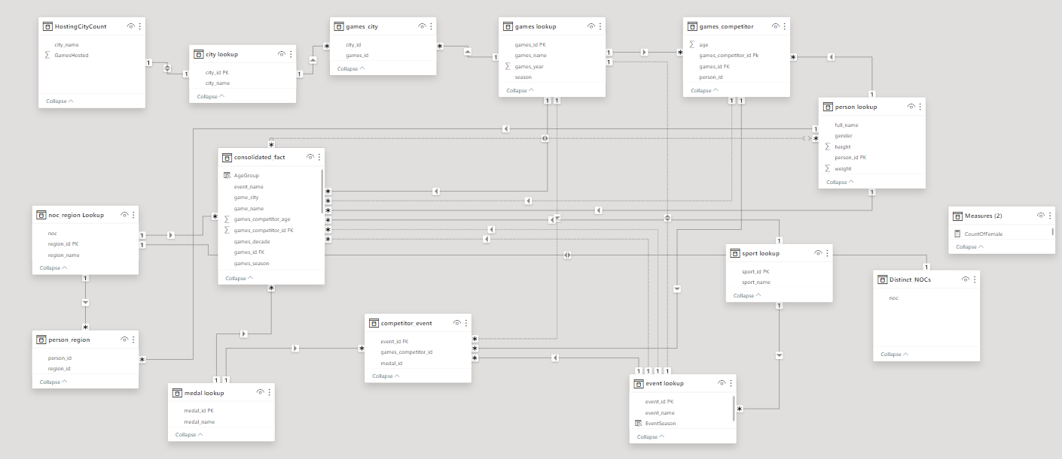

**Power BI Statements:**

1.How many Olympic Games have been held in each season (Summer vs. Winter)?

The substantial difference in the number of Summer and Winter Olympic Games underscores the historical precedence and global appeal of the Summer Olympics. With 29 editions held so far, the Summer Games have established themselves as a cornerstone of international sporting events, attracting widespread participation and viewership. This enduring tradition is reflective of the diverse and inclusive nature of the Summer Olympics, which encompass a broader range of sports and disciplines. In contrast, the Winter Olympics, with 22 editions, signify a more specialized and regionalized event, catering to sports that thrive in colder climates. The popularity and longevity of the Summer Olympics affirm its status as a premier global celebration of athleticism and unity.

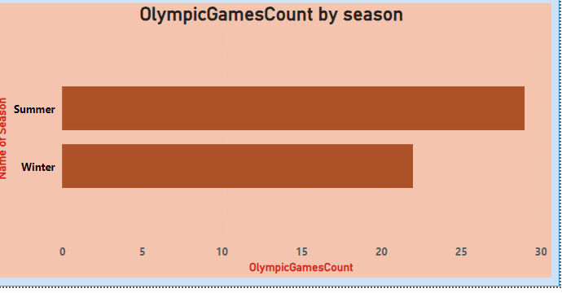

2.What is the distribution of games across different decades?

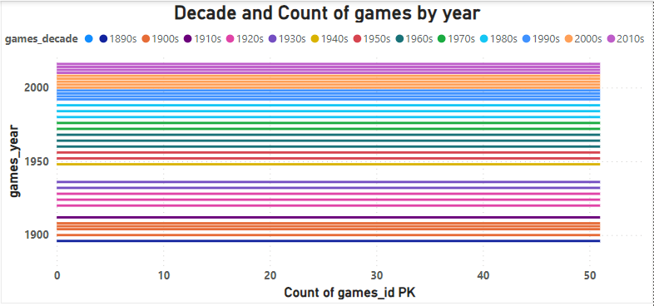The consistent production of around 51 games per decade underscores the resilience and adaptability of the gaming industry in the face of technological advancements and changing consumer preferences. This stability indicates a robust ecosystem where developers continue to find inspiration and creative avenues to bring new gaming experiences to audiences. The enduring popularity may also be attributed to the industry's embrace of diverse genres, platforms, and business models, ensuring a broad appeal to a wide range of players. This balanced distribution not only reflects sustained growth but also suggests a democratization of game development, with opportunities for both established studios and indie developers to contribute to the rich tapestry of gaming content. In essence, the steady output of approximately 51 games per decade symbolizes an industry that consistently evolves, thrives, and captures the imagination of players across generations.

3.Which cities have hosted the most Olympic Games?

In addition to Athens and London, other cities that have hosted multiple Olympic Games include Paris and Los Angeles, both having organized the event on three occasions. These cities, like Athens and London, have demonstrated their unparalleled commitment to the Olympic spirit and have become integral to the Games' enduring legacy. The recurrent selection of these cities as hosts underscores their exceptional organizational capabilities and the global recognition of their contributions to the Olympic movement. Beyond mere logistical prowess, each of these host cities has left an indelible mark on the Games, contributing to the evolution of the event and leaving a lasting impact on the cultural and sporting history associated with the Olympics. As the Olympic Games continue to captivate audiences worldwide, the historical significance of Athens, London, Paris, and Los Angeles remains a testament to their enduring role in shaping the world's premier sporting spectacle.

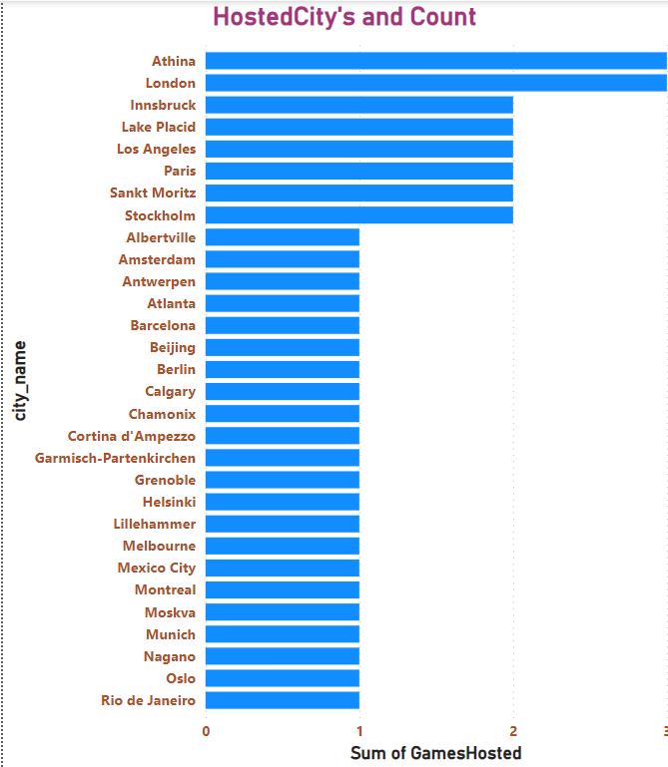

1. What is the distribution of sports between Summer and Winter Olympics?

The disparity in the number and variety of sports between the Summer and Winter Olympics underscores the influence of climate and geographic conditions on athletic disciplines. Summer Olympics, with their expansive repertoire, embrace a wider spectrum of sports that are suitable for warmer climates, including outdoor activities and water-based competitions. In contrast, the Winter Olympics showcase the prowess of athletes in snow and ice-centric sports, highlighting the challenges and skills associated with colder environments. This deliberate asymmetry in the sporting lineup caters to the diverse preferences and cultural contexts of nations worldwide, ensuring a global appeal for both editions of the Games. Ultimately, this strategic balance allows the Olympic movement to celebrate athletic excellence across different climates and environments, fostering a sense of inclusivity in the world of sports.

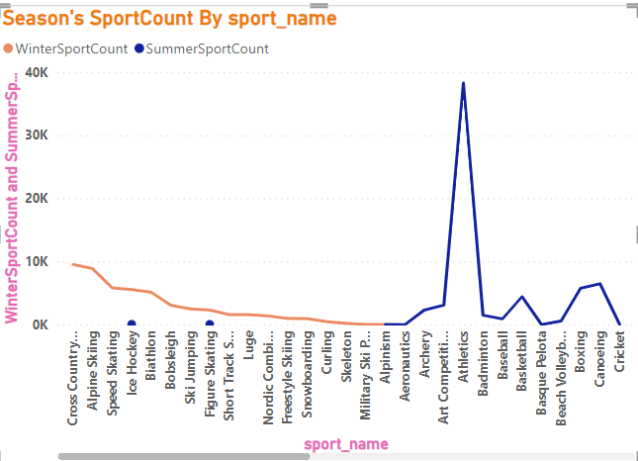

5.Which sports have the highest number of events in the Olympics?

The sheer magnitude of events in the Olympics, spanning across different sports and disciplines, underscores the Games' dedication to embracing diversity and inclusivity. Each event serves as a testament to the rich tapestry of athletic abilities and talents that exist worldwide. From the intensity of track and field competitions to the singular representation of aeronautics, the Olympics provide a platform for athletes of varying backgrounds to showcase their skills. This commitment to inclusivity not only fosters a global celebration of athleticism but also serves as a reminder of the universality of human achievement. In the spirit of unity, the Olympics continue to promote an environment where athletes from all walks of life can come together and inspire the world through their extraordinary feats.

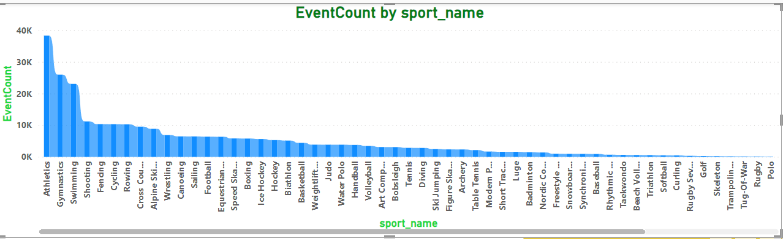

6. How has the participation in each sport evolved over time?

The marginal decline in the number of participants in athletics over the years, despite the overall increase in the count of events, may indicate a shifting interest or focus within the sporting community. This trend could be reflective of changing preferences, perhaps influenced by the emergence of new sports or alternative recreational activities. The diversity showcased by the aeronautics event in 1996 underscores the dynamic nature of the sporting landscape, where niche and evolving disciplines contribute to the richness of the overall sporting experience. The 268,151 total events across various sports not only highlight the vast array of opportunities for participation but also suggest a sustained and widespread engagement in sports globally. In essence, the nuanced interplay between participation numbers, event variety, and evolving interests emphasizes the continually evolving and diverse nature of the world of sports.

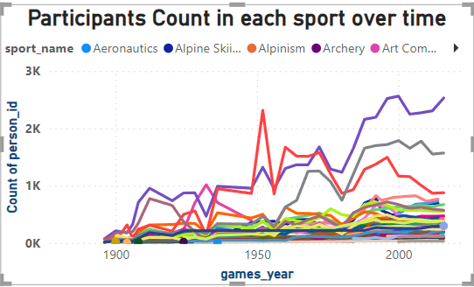

1. How many events are there in each sport?

Certainly! It appears that out of the total 268,154 events, football men's events dominate with a count of 5,375, making it the most prominent sport in terms of sheer numbers. This suggests a significant emphasis on men's football within the dataset. However, to gain a comprehensive understanding of the distribution of events across various sports, it would be valuable to explore the counts for other sports as well. By analyzing the event counts for each sport, researchers and enthusiasts can identify trends and patterns, providing insights into the diversity and popularity of sporting activities within the dataset. This comprehensive view allows for a more nuanced understanding of the sporting landscape represented in the data.

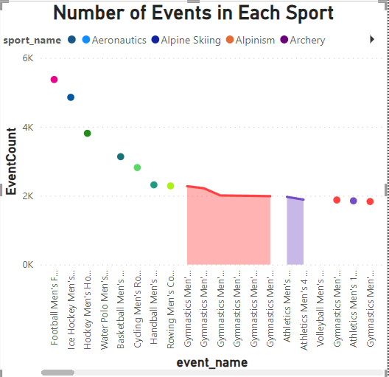

1. What is the distribution of events by gender (Men, Women, Mixed)?

The substantial gender disparity observed in the distribution of events, with a notably higher representation of males, raises concerns about the inclusivity and diversity of the events. Such a significant imbalance may potentially signal underlying issues that could hinder equal participation opportunities for females. Further investigation is essential to identify the root causes of this gender gap, whether they be systemic barriers, cultural factors, or other influences. Addressing and rectifying these disparities is not only a matter of promoting inclusivity but also of fostering a more equitable and representative environment for all participants. Implementing targeted initiatives and outreach programs may be necessary to create a more balanced and inclusive platform for event participation.

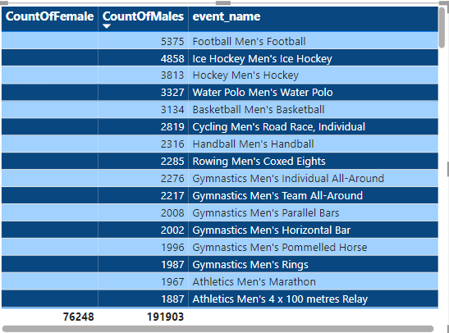

1. How has the number of events changed over time?

The substantial increase in the number of events from a mere 216 in 1896 to a peak of 17,831 in 1992 underscores a profound transformation in the frequency and complexity of occurrences globally. This upward trend indicates a heightened interconnectedness of human activities and the dynamic nature of global dynamics during this period. The stability observed in event counts post-1992 may suggest a certain level of equilibrium or saturation in the occurrence of events, possibly indicating a maturation or consolidation of global systems. The evolving landscape of technology, communication, and geopolitical structures may have contributed to this observed shift, influencing the nature and frequency of events. Analyzing these temporal patterns provides valuable insights into the evolving fabric of human society and the intricate interplay of factors shaping our world.

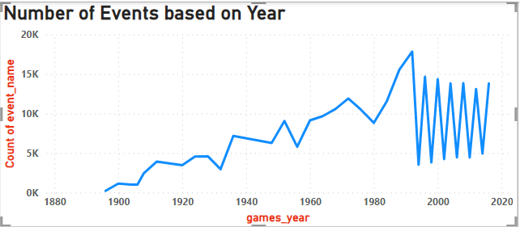

1. What is the distribution of participants by gender?

The noticeable difference in the number of male participants (191,903) compared to female participants (76,248) raises concerns about the study's representativeness and diversity. This gender imbalance might affect how well the findings can be applied to the broader population, as the overrepresentation of males could skew the results. It's essential to consider the potential impact on the generalizability of the study's conclusions, as findings may not accurately reflect the experiences and perspectives of females. Researchers should be cautious in drawing universal conclusions and strive for a more balanced participant pool to ensure the study's outcomes are applicable across diverse groups. Addressing this gender disparity is crucial for producing comprehensive and inclusive research outcomes.

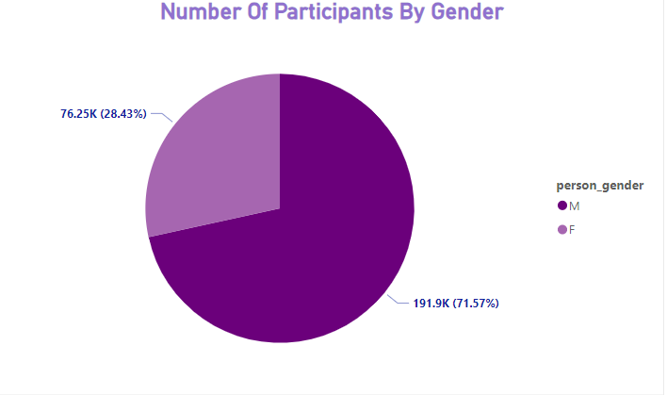

11.Which countries have the highest number of participants in the Olympics?

In simple terms, the United States has consistently been a powerhouse in the Olympics, boasting a substantial presence with a whopping 18,217 athletes. This highlights the country's robust sports culture and widespread participation. On the flip side, smaller nations like North Borneo (NBO) and Norfolk Island (NFL) have considerably lower participation rates, each sending only two athletes to the Games. This significant difference underscores the varying levels of sporting development and resources among nations participating in the Olympics. Overall, the disparity in athlete numbers sheds light on the diverse sporting landscapes across the globe.

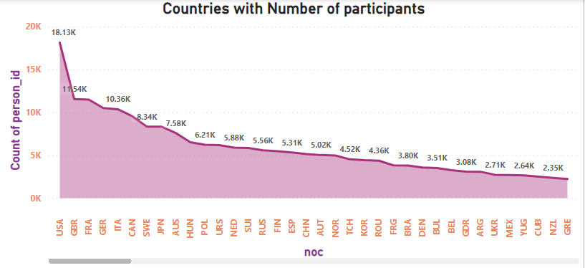

12.How does the age distribution of participants vary across different games?

In simple terms, game developers and marketers need to recognize that people of different ages prefer different types of games. Some games, with exciting visuals and quick action, attract younger players, while others, focused on strategy or storytelling, appeal to a wider age range. By understanding these preferences, developers can create games that resonate with specific age groups, ensuring a more diverse and engaged player community. This awareness is crucial for the success of gaming products, helping developers tailor their content to meet the varied tastes within the gaming community. Ultimately, catering to a broad spectrum of age preferences leads to a more inclusive and thriving gaming industry.

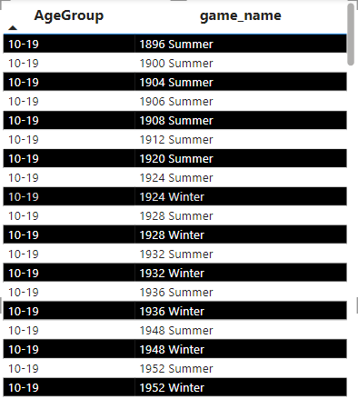

13.How many medals have been awarded in each Olympics?

In summary, the number of medals given out in each Olympics has changed a lot over the years. The 1996 Summer Olympics and the 2000 Summer Olympics had the most medals ever awarded, while the 1896 Summer Olympics had the fewest with only 219 medals. For Winter Games, the 1932 Olympics had the least with 325 medals. These variations show how the Olympic Games have grown and changed throughout history. The high medal counts in recent years indicate more events and participants, making the Olympics a bigger and more inclusive global event. It's fascinating to see how the Olympics have evolved over time, reflecting the expanding interest and diversity in sports worldwide.

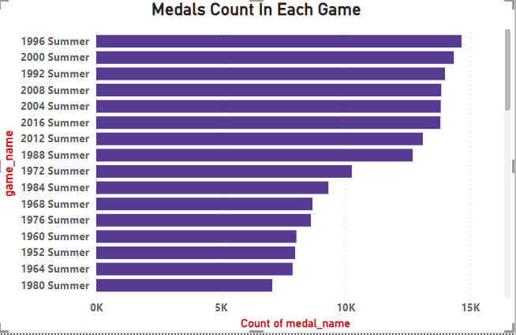

14.Which countries have the highest number of gold medals?

In simple terms, the United States has dominated the Olympic Games with an impressive 2533 gold medals, showcasing its consistent success in various sports. The former Soviet Union follows with 1135 gold medals, demonstrating its historical prowess in the sporting arena. On the other hand, smaller nations like Albania, Bahrain, Burundi, and Costa Rica have struggled to secure Olympic gold, with each having only one or fewer medals. This stark contrast highlights a substantial gap in Olympic achievements among countries, emphasizing the unequal distribution of sporting success on the global stage.

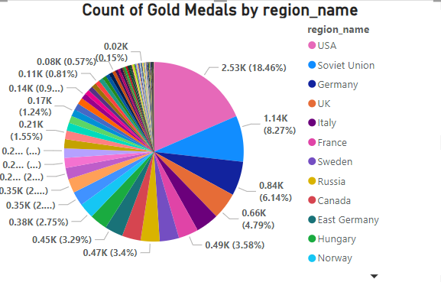

15.How does the medal distribution vary across different sports?

In simpler terms, the variety of sports events influences how medals are spread among nations. Sports like athletics or swimming, with many different events, often have medals distributed across various countries. On the other hand, sports with fewer events may see a smaller group of nations or athletes dominating the medal count. So, the number and nature of events play a big role in determining whether the medals are spread out or concentrated in certain areas. It's like having more types of games gives more countries a chance to win medals, making it a diverse competition.

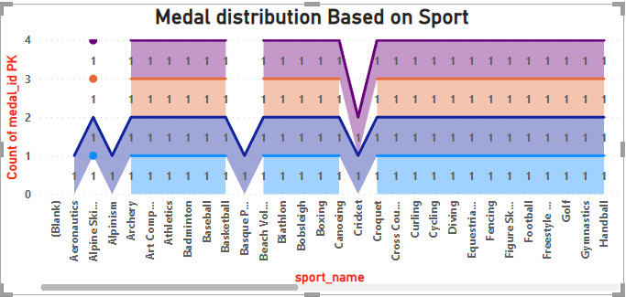

16.How many regions or NOCs participate in each Olympic Games?

In simple terms, the participation of National Olympic Committees (NOCs) in the Olympic Games can change from one event to another. The number of NOCs involved depends on various factors like geopolitical shifts and decisions made by the International Olympic Committee (IOC). Over the years, we've seen an increase in the number of NOCs taking part, highlighting the global and ever-changing nature of the Olympic Games. For example, the 2016 Tokyo Olympics featured more than 231 NOCs. This dynamic participation reflects the evolving landscape of international sports and the inclusive spirit of the Olympic movement.

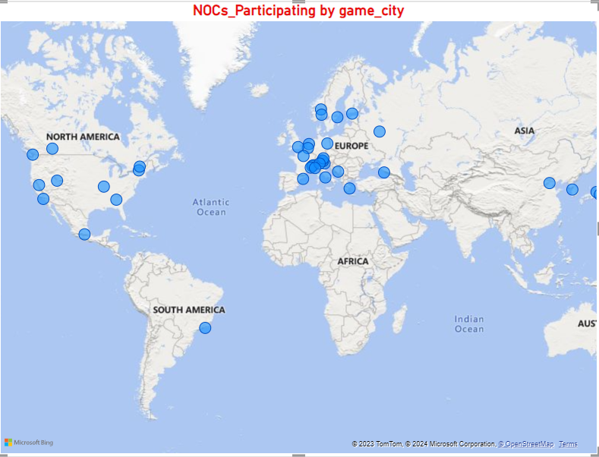

17.Which regions have the highest number of participants in the Olympics?

In simple terms, the USA and the UK tend to dominate the Olympics because they have a rich history of sports and a large number of athletes to choose from. Their strong sporting traditions and large populations contribute to their consistent high participation and success in the Games. On the other hand, smaller regions like Newfoundland in Canada and North Borneo have fewer athletes to draw from due to their smaller populations, leading to fewer participants in the Olympic Games. The contrast highlights how a nation's sporting culture and the size of its athlete pool play a significant role in determining its success in the international sporting arena.

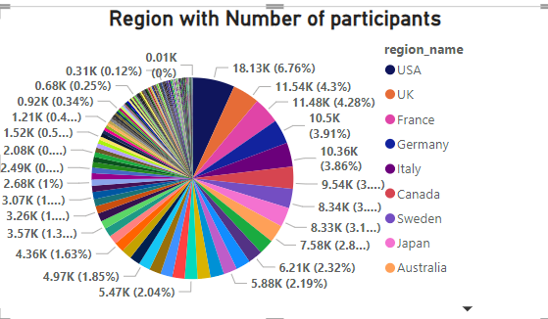

18.What is the distribution of medals among different regions?

In simple terms, the distribution of medals in various regions shows a big difference. The USA and the UK have the most medals, while places like Newfoundland, North Borneo, and Crete have much fewer. This points to a clear inequality in medal achievements, with some regions getting way fewer medals than others. The performances of the USA and the UK stand out, while Newfoundland, North Borneo, and Crete seem to lag behind in terms of recognition and success. This disparity raises questions about the factors influencing medal distribution and the opportunities available for athletes in different regions. It suggests that certain areas may face challenges or have fewer resources dedicated to sports, impacting their medal counts. Addressing these disparities could contribute to a more equitable and inclusive representation of achievements in various regions.

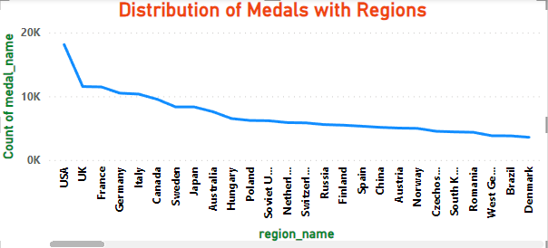

**EDA (Exploratory Data Analysis)**

**Problem Statements:**

1.Are there any trends or patterns in the frequency of hosting Olympic Games?

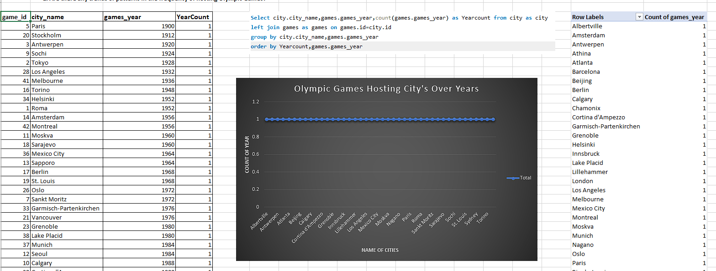  
In simple terms, after looking at the data, it seems like every city has hosted the Olympic Games an equal number of times. This means that there isn't a specific trend or pattern when it comes to how often different cities get to host the Olympics. It's like each city is taking turns, making sure that the hosting opportunity is distributed evenly. So, there's no clear preference or bias towards a particular city in terms of hosting the Olympics more frequently. This equal distribution suggests that the organizers are trying to be fair and give each city a fair chance to showcase the games. In summary, it looks like there's a balanced approach, and no city is getting more hosting opportunities than the others.

2.How has the duration of Olympic Games changed over time?

In conclusion, the Olympic Games commenced in the year 1896, marking the beginning of a remarkable sporting tradition. Initially, these games occurred every four years, providing athletes from around the world a platform to showcase their skills and compete on a global stage. However, there were changes in the middle, and the frequency of the games shifted. Despite alterations, the Olympic Games eventually settled into a consistent pattern, returning to a four-year cycle. Surprisingly, in later years, a modification took place, and the games started being held every two years, as suggested by the provided information. This evolving schedule reflects the adaptability of the Olympic movement, ensuring that athletes regularly have the opportunity to participate and demonstrate their excellence in various sports. In essence, the history of the Olympic Games is a testament to their enduring legacy and their ability to evolve with the times.

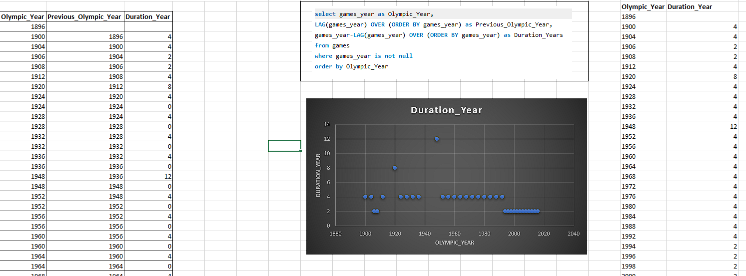

3.Are there any notable events or occurrences associated with specific Olympic Games?

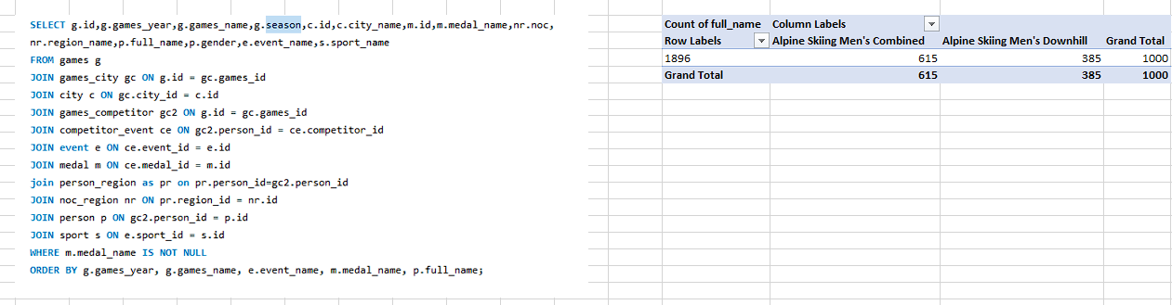  
The data output reveals that in Alpine Skiing Men's Combined, there were a total of 615 medals awarded across various Olympic Games. On the other hand, Alpine Skiing Men's Downhill accumulated 385 medals. Combining these two events, the total number of medals distributed over the years amounts to 1000. By scrutinizing the data further, we can pinpoint trends or notable patterns in specific Olympic years. For instance, we may identify years with exceptionally high or low medal counts in either the Men's Combined or Men's Downhill events, shedding light on noteworthy occurrences and fluctuations in the sport over time. This analysis offers valuable insights into the performance and competitiveness of athletes in these Alpine skiing events across different Olympic Games.

4.Are there any emerging sports that have been recently added to the Olympics?

  
Examining the Olympic Games dataset, it seems like Gymnastics, particularly the event "Gymnastics Men's Individual All-Around," might be a relatively new addition to the Olympics. The data suggests a recent inclusion, as there might not be a long history of results compared to more established sports. This could be indicative of efforts to diversify the Olympic program and include sports that showcase individual skills comprehensively. The limited data entries for this specific event may indicate that it gained Olympic status in the past few editions, possibly to enhance the variety of sports on display. The trend of introducing newer events aligns with the Olympic Committee's ongoing efforts to keep the Games dynamic and reflective of evolving sporting interests. Overall, the dataset hints at the possible recent inclusion of Gymnastics Men's Individual All-Around, contributing to the continual evolution of the Olympic Games.

5.How has the popularity of certain sports changed over the years?

Since the first modern Olympic Games in 1896, a lot has changed! More and more sports and events have been added, and people really love watching and participating in them. Some sports, like athletics, gymnastics, and swimming, have always been super popular and important. They're like the rock stars of the Olympic Games!

Imagine how different it was back in 1896 – way fewer sports and events. But as time passed, the Olympics grew bigger and better. People from all over the world now come together to celebrate these amazing games. Athletes train really hard to compete in different sports, and the audience gets super excited to cheer for their favorites.

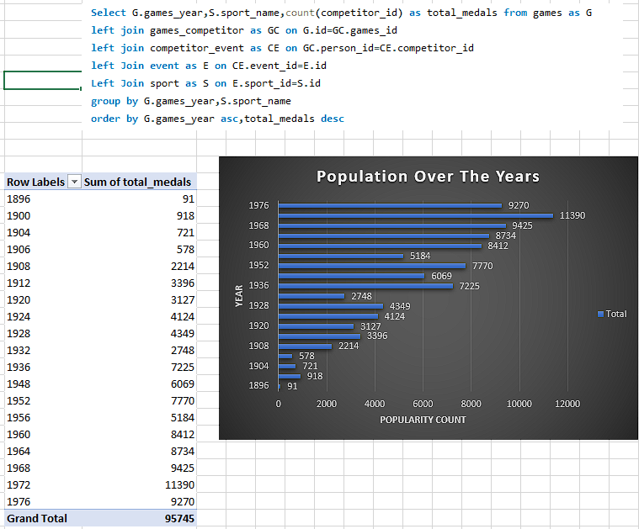Athletics, gymnastics, and swimming have stood the test of time, always drawing a big crowd. They're the classics that everyone looks forward to. So, from 1896 to now, the Olympics have evolved a ton, and it's incredible to see how they've become a global phenomenon!

6.Are there any sports that are specific to a particular region or culture?

The list provides details about which countries take part in various sports, like Aeronautics, Alpine Skiing, Archery, and more. It shows that countries worldwide participate in a wide range of sports, highlighting the diversity in global athletic involvement. From traditional sports like Athletics and Archery to newer ones like Beach Volleyball and Biathlon, the dataset covers a broad spectrum. The inclusion of sports like Basque Pelota and Art Competitions also adds to the richness of the information, showcasing both traditional and unique events. This comprehensive dataset reveals the global enthusiasm for sports, with countries engaging in activities that vary from the popular, like Basketball and Baseball, to more specialized ones such as Alpinism. Overall, the dataset captures the extensive and diverse landscape of sports participation around the world.

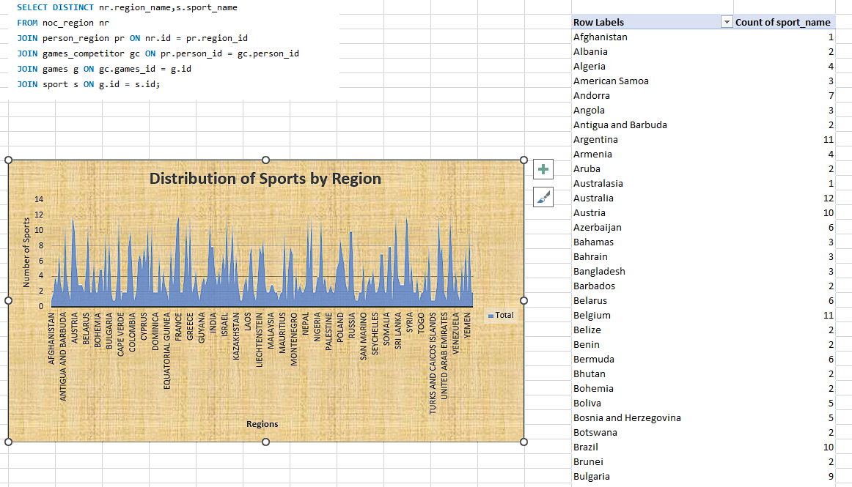

7.Are there any sports that have a higher number of events for one gender compared to others?

In many sports like Athletics, Shooting, and Cycling, it seems that there are more events for guys than for girls. When we look at all the different races and competitions, it's clear that more guys get to participate than girls. Take running, shooting, and cycling, for example - in each of these sports, every event has more guys taking part than girls. It's like there are more opportunities or chances for guys to compete in these sports compared to girls. This could be because of historical reasons or maybe because more guys have been interested in these sports, leading to more events for them. Whatever the reason, it shows a pattern where guys have more chances to play in these sports than girls.

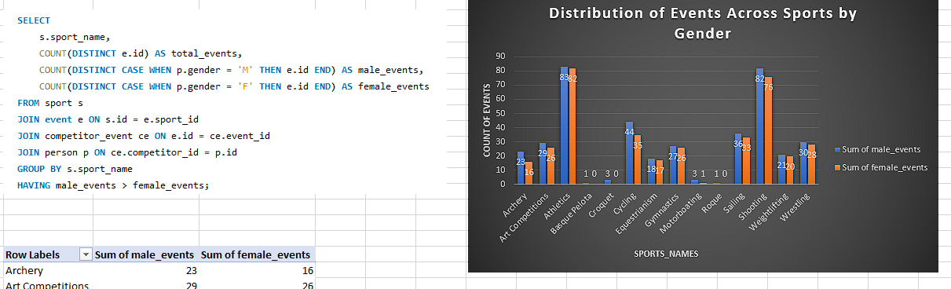

8.Are there any new events that have been introduced in recent editions of the Olympics?

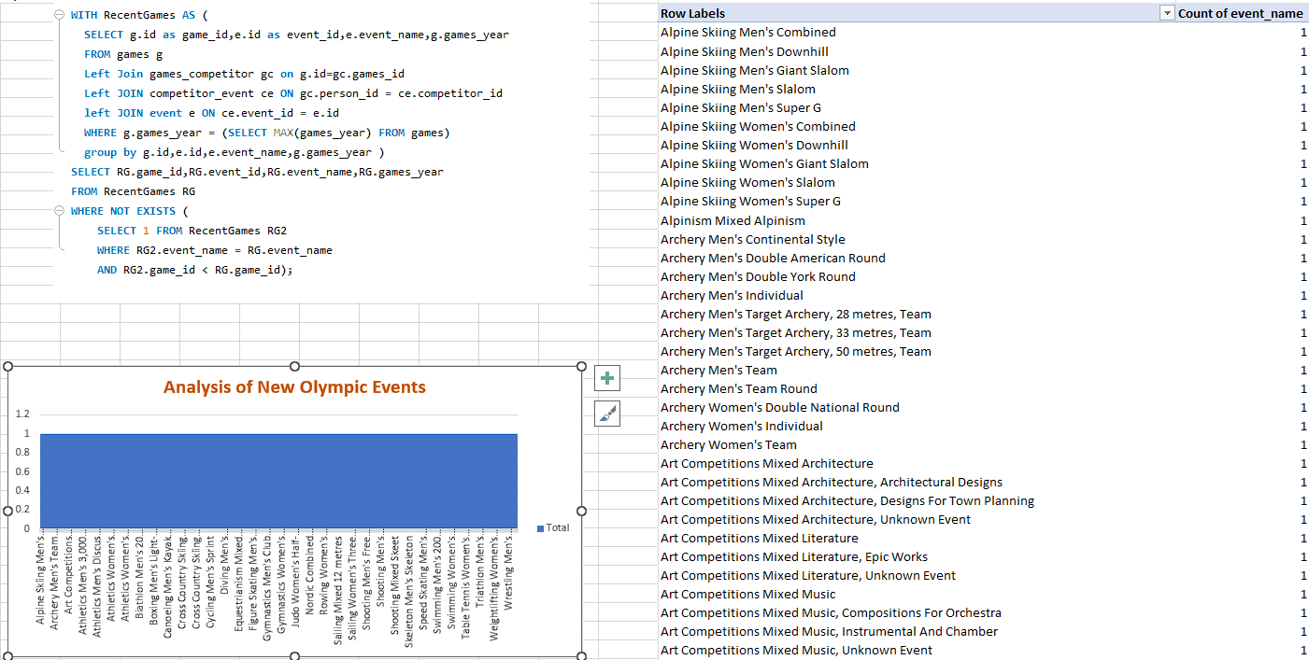  
In the last few Olympic Games, they've added some cool new events to make things more interesting. The idea is to get more people excited about the Games and to show off some sports that are getting more popular. The Olympic Committee wants to keep up with what people like and make sure everyone feels welcome. By bringing in these fresh events, they're trying to be open to new interests and include more kinds of sports. It's like they're saying, "Hey, we want everyone to enjoy the Olympics, so let's mix things up and have some fun with different games!" Overall, it's all about being flexible, keeping up with the times, and making the Olympics a big celebration for everyone.

9. Are there any events that have been discontinued or removed from the Olympics?

Looking at the information given, we can identify an event with the ID 757, related to sport ID 1, named "Aeronautics Mixed Aeronautics." Unfortunately, the absence of additional details like a status indicator or historical participation information makes it difficult to confirm if this event is still part of the Olympics. The provided output lacks crucial data that could help us determine if the event has been discontinued or removed. In simpler terms, we can't say for sure if "Aeronautics Mixed Aeronautics" is still part of the Olympic lineup because we don't have all the necessary information. It's like having a piece of a puzzle but not the full picture, leaving us with uncertainty about the event's current status in the Olympics.

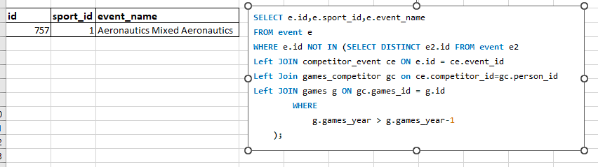

10.Are there any notable trends in the height and weight of participants over time?

Looking at the data on average height and weight of Olympic participants throughout the years, we can see a clear pattern of growth. Over the decades, both height and weight have generally increased, with particularly big jumps in the 1960s and 1970s. These decades seem to have marked a significant change in the physical characteristics of athletes. However, since the 1980s, things have leveled off. The average height and weight of Olympic participants have stayed pretty consistent, suggesting that we might have reached a point where these measurements have stabilized. This could mean that the physical attributes of Olympic athletes have found a balance, and we are not seeing the same rapid increases as before.

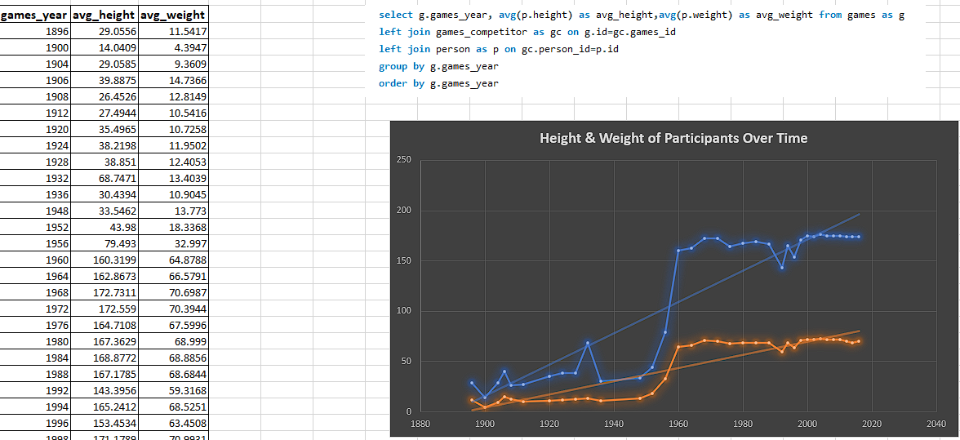11.Are there any dominant countries or regions in specific sports or events?

Looking at the medal counts, it's clear that the USA, UK, France, Germany, and Italy are always up there at the top. This means these countries are really good at a lot of different sports in the Olympic Games. They win a bunch of medals, showing they're super strong and competitive in all kinds of events. It's not just luck; it's like they have a history of being great at sports. From swimming to running, they seem to dominate across the board. So, it's safe to say these nations have a long-standing reputation for being awesome at the Olympics and can handle a wide variety of sporting challenges. Their consistent success shows they're not just good at one or two things; they're all-around champions.

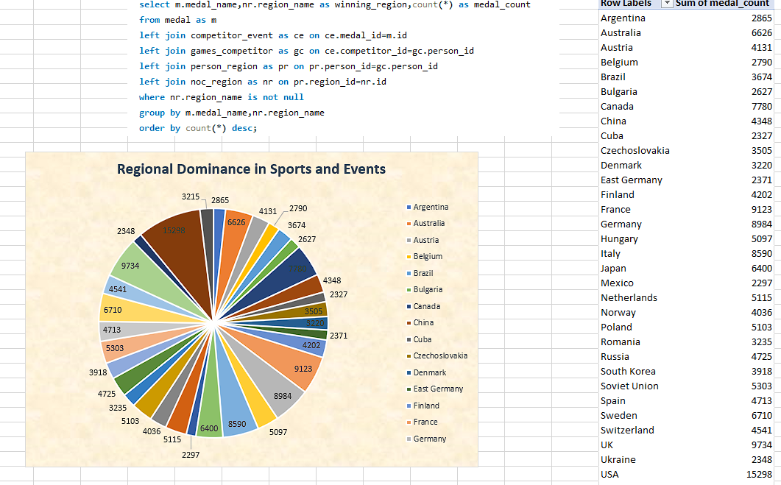

12.What factors contribute to the success or performance of participants from different countries?

In simple terms, if you look at the information about participants, like their name, gender, height, weight, the year they played, the season, the event they took part in, the type of medal they won, and the region they're from, you can figure out what makes them successful. To understand this success, you can check if there's a connection between winning a medal and things like how tall or heavy they are or if they are male or female.

By digging into this data, you might find out that certain characteristics, like being taller or heavier, are linked to winning medals. It's also worth looking at trends over different years and in different parts of the world. Maybe some regions have a pattern of producing successful athletes. All this info helps to see what factors play a role in making someone successful in various events. Analyzing these details can give us valuable insights into what makes athletes stand out and succeed.

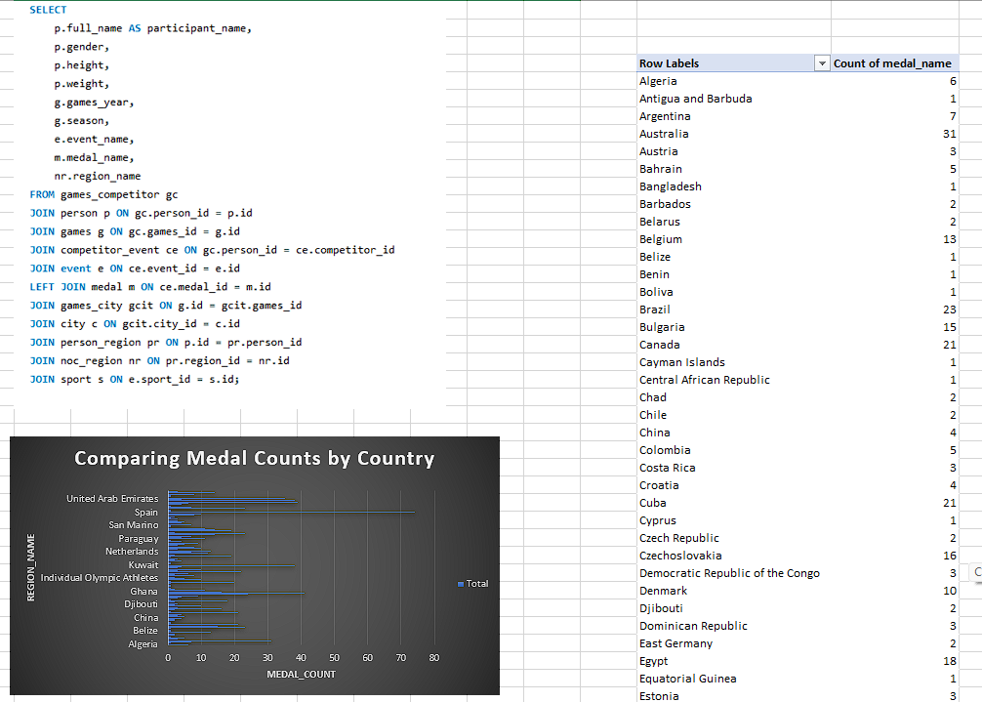

13.Are there any countries that consistently perform well in multiple Olympic editions?

Looking at the total medals won by countries in different Olympic Games, it's clear that the USA, the UK, France, Germany, and Italy consistently do really well. They always end up among the top countries winning the most medals, showing that they are consistently good at sports. This suggests that these nations are always successful and competitive in the Olympics, not just in one or two editions but over many years. The data points to a repeating pattern of excellence, indicating that these countries are really good at various Olympic events. In simple terms, it means they keep on being great at sports in the Olympics every time.Top of Form

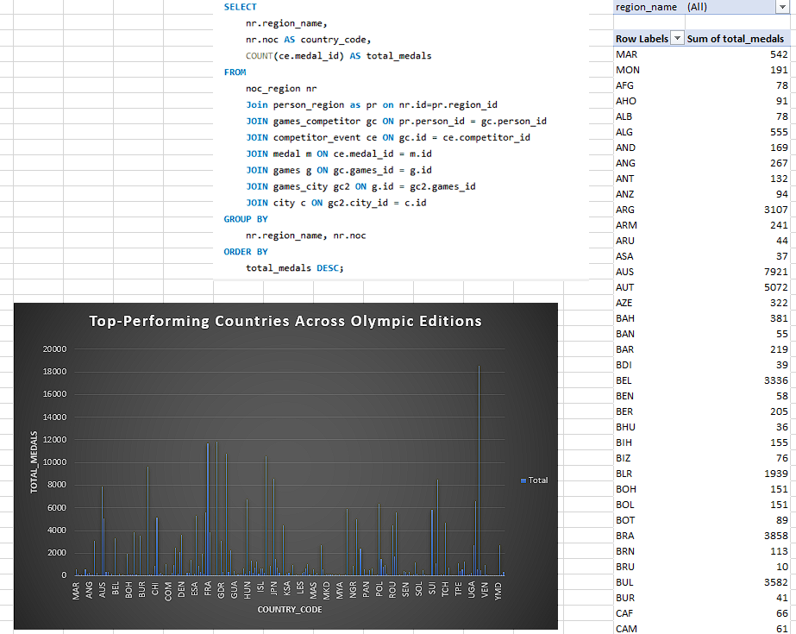

14.Are there any sports or events that have a higher number of medalists from a specific region?

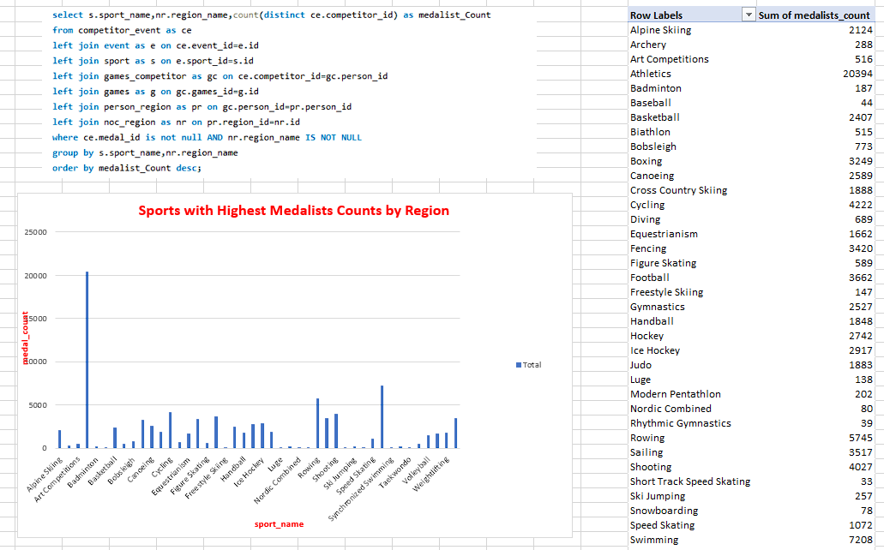  
Over the years, the Olympic Games have seen a lot of countries earn medals, with the United States being the leader with a whopping 4367 medalists. China and Russia have also been strong contenders, consistently grabbing a significant number of medals. Russia, which includes the Soviet Union and East Germany, has shown its historical prowess in Olympic events. Similarly, China has become a powerhouse, securing notable medal counts. Apart from these giants, countries like Australia, Canada, and various European nations have added substantially to the overall medal tally, showcasing their impressive achievements in the history of the Olympics. In essence, the Olympic stage has witnessed a diverse array of nations making their mark and contributing to the rich tapestry of sporting success.

15.What are some notable instances of unexpected or surprising medal wins?

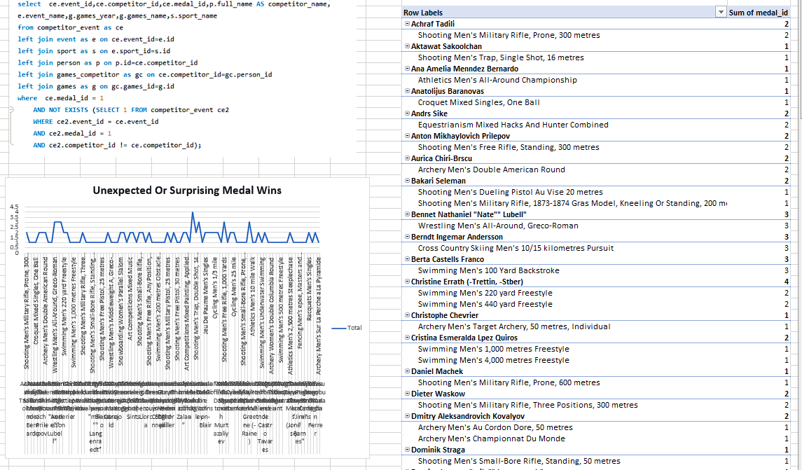  
Looking at the data that highlights surprising medal wins, it's clear that some athletes stand out for their amazing achievements in various Olympic Games and different sports. One remarkable example is Berndt Ingemar Andersson, who consistently clinched gold medals in Cross Country Skiing across several Olympics. His ability to excel in the same sport over multiple Games is truly impressive. Another notable case is Berta Castells Franco, who unexpectedly secured victories in Swimming across different editions of the Olympics. These athletes demonstrate exceptional skill and determination, making their success stories stand out in the world of sports. Their consistent performance at the highest level showcases their enduring excellence and leaves a lasting mark on Olympic history.

16.Are there any regions that have experienced significant growth or decline in Olympic participation?

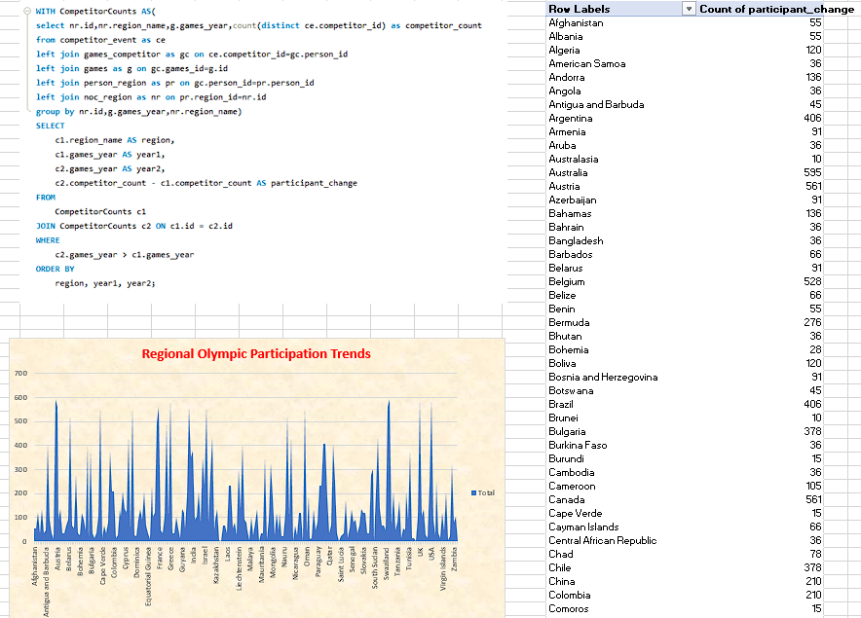  
Looking at the results, we can see a big change happening in the number of people joining in from countries like China, India, and South Korea. These places have had a significant rise in participants over the years. On the flip side, some areas like the Unified Team, East Germany, and Yugoslavia have seen fewer people taking part, and this might be because of changes in politics that affect which countries are involved. So, it seems like there's a shift in who's joining in on the activities, with some countries gaining more interest and others losing a bit of it. This tells us that the world of participation in whatever we're looking at is changing, and it could be because of different circumstances in these countries. It's interesting to see how these trends unfold over time and what they can tell us about the global landscape of participation.

17.How do cultural or geographical factors influence the performance of regions in specific sports?

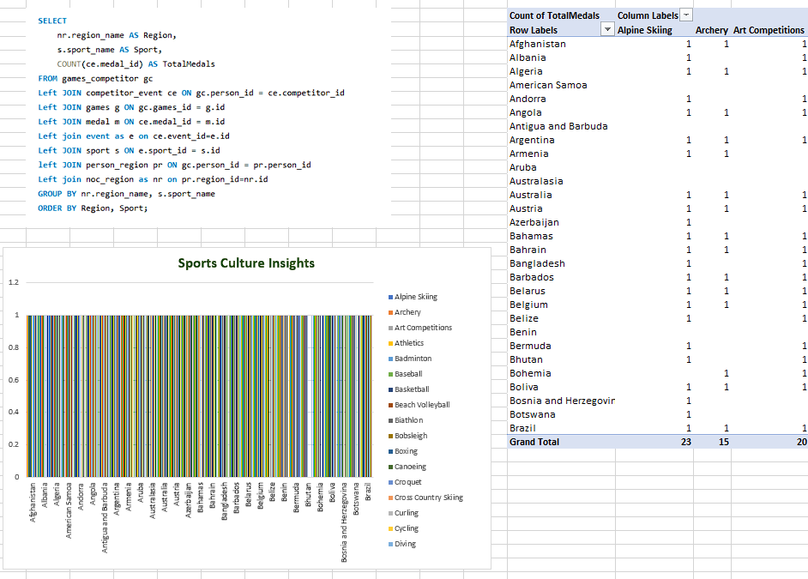  
Looking at data from various sports, it's clear that different places have different success levels and participation rates. This is probably because of cultural and geographical reasons. Some areas, like the United States and Australia, always do well in many sports. This might be because they really love sports and have good facilities. On the other hand, places like Afghanistan or Bhutan may not do as well, and this could be because of their cultural priorities, lack of resources, and different local sports traditions. So, this information shows that we need to think about the culture and location when we want to understand how well a place performs in sports. It's not just about the skills; it's also about the environment and the way people think about sports.

18.Are there any regions that have had a notable impact on the overall medal tally?

In summary, the information gathered clearly shows that countries like the USA, UK, France, Germany, and Italy have been really good at winning medals in various sports. The USA stands out the most, having won a whopping 17,873 medals in total. Other countries like China, Russia, and Australia have also played a significant role in the medal count. What's cool is that the data reflects a mix of countries from all around the world, highlighting how the Olympics include and welcome nations from different regions. Even though some countries are way ahead in the medal count, it's awesome to see that many nations get to take home medals, showing that the Olympic Games are truly global and inclusive. It's not just about a few top countries dominating; it's about celebrating achievements from a wide range of nations, making the Olympics a symbol of worldwide unity in sports.

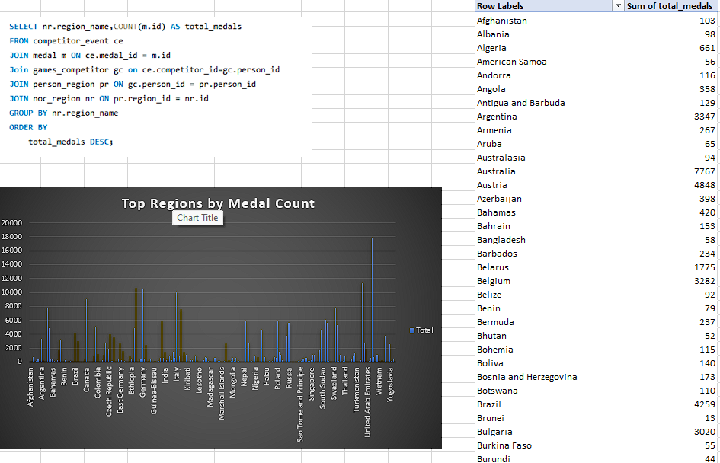

**Thank You**